River Management Society - NW Chapter
Rogue River Lodge-to-Lodge Trip: October 1st- 3rd, 2020
Optional pre-trip single-day float: September 30th, 2020

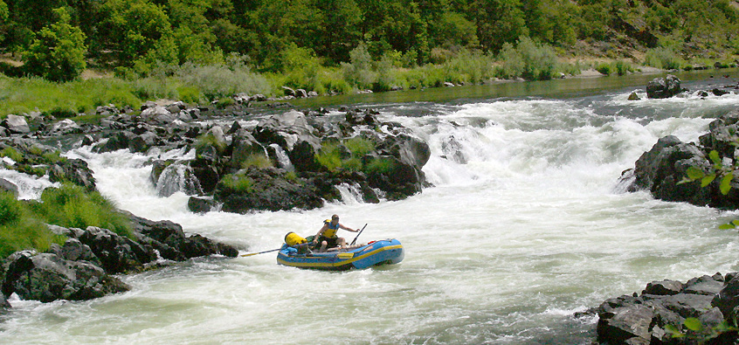

The Northwest Chapter of RMS, in partnership with the BLM Medford District-Grants Pass Resource Area and Rogue River Siskiyou National Forest, is hosting a September-October Lodge-to-Lodge river trip on the Rogue Wild and Scenic River in southwestern Oregon.

From the headwaters near Crater Lake National Park, the Rogue River flows 215 miles to the Pacific Ocean at Gold Beach, Oregon. Eighty-four miles of the lower Rogue, beginning 7 miles west of Grants Pass and ending 11 miles east of Gold Beach was one of the original eight rivers included in the Wild and Scenic Rivers Act of 1968. It is also designated as an Oregon State Scenic Waterway. This portion of the river is managed cooperatively by the Medford District BLM and the Rogue River-Siskiyou National Forest. The Rogue is well known for its challenging whitewater, steelhead and salmon fishery, and extraordinary wildlife viewing opportunities. It is surrounded by forested mountains and rugged boulder and rock-lined banks.

The Northwest Chapter Lodge-to-Lodge trip will launch from the Almeda Park Campground put-in on October 1st and take-out at Foster Bar on October 3rd, for a total trip length of 38 river miles (3 days/2 nights). The wild section of the river is Class II-III (IV) pool-drop river. As flows drop the river gets more technical, rafts and kayaks are the preferred watercraft for this float. Rafters should be comfortable with Class III+ rapids. There is one class IV rapid located at Blossom Bar. Kayakers should have solid Class III+ experience, at a minimum. If you don’t have the experience, it’s OK! There will be some open seats on experienced boater’s watercraft. Let us know, and we will do our best to arrange an open seat for you!

There is an optional pre-trip single-day float (13 mi.) from Robertson Bridge to Almeda on September 30th on the recreational section of the Rogue WSR. Participants in the pre-trip float will camp at Almeda prior to the main trip’s launch on the morning of Oct. 1st. This stretch of river has mostly Class 1 and 2 rapids, with one Class III rapid (Argo).

Trip Logistics

Registration: Trip sign up is first-come, first-served and is limited to 14 participants (including host staff). Cost is $350 for lodge-to-lodge trip ONLY; $400 for lodge-to-lodge AND optional pre-trip float. Trip is open to current NW Chapter RMS members. Registration will open to all RMS members after April 20th (space permitting). No refunds for cancellations.

Registration will close May 20th or when the maximum group size of 14 people is met, whichever comes first. A waiting list will be maintained in the event of a cancellation. Please keep in mind that registration fees are non-refundable – be sure of your availability before registering.

Registration will be open from now until April 20, 2020 for RMS NW chapter members (open to all RMS members after April 20, space permitting). Cost is $350 per person for lodge-to-lodge trip ONLY; $400 for lodge-to-lodge AND optional pre-trip float. Cost includes food, starting with dinner for the first night and ending with lunch on the last day. (Shuttle not included in cost - RMS will arrange shuttle once registration closes)

Mail registration form with a check payable to “ Joni Gore” to:

Joni Gore
8770 Sand Point Way NE
Seattle, WA 98115

Pre-Trip Float Information: Participants should arrive at Robertson Bridge Boat Launch by 8:00 am Pacific Time on Wednesday September 30th. Shuttle arrangements TBD.

Meals: Meals from dinner on Wednesday September 30th through lunch on October 3rd will be provided. Breakfast and lunch on Wednesday September 30th are on your own.

Shuttles: Shuttles are not included in the cost. RMS will arrange group shuttles with a local company once registration closes. The cost of a shuttle from Roberston Bridge to Almeda is around $40/vehicle.

Lodge-to-Lodge Float Information: Participants not joining the Pre-trip float should arrive at Almeda Park Campground by at least 8:00 Pacific Time on Thursday October 1st on the morning of the launch, to prep boats and gear. Launch time will be no later than 10:00 AM. Participants will stay at Black Bar Lodge Thursday night and at Paradise Lodge Friday night. Take-out will be Saturday at Foster Bar sometime around noon. Shuttle arrangements TBD.

Meals: Meals from dinner on Thursday October 1st through lunch on October 3rd will be provided. Breakfast and lunch on Thursday October 1st are on your own.

Shuttles: Shuttles are not included in the cost. RMS will arrange group shuttles with a local company once registration closes. The cost of a shuttle from Almeda to Foster Bar is around $150/vehicle.

Personal boat use: Oregon Waterway Access Permit- - Anyone who wishes to launch their boat in Oregon waters is required to purchase an OR Waterway Access Permit. You can purchase one anywhere you can buy a Oregon fishing license. This license is required to legally launch and operate your boat in Oregon. Permits can also be purchased online:

https://myodfw.com/articles/waterway-access-and-aquatic-invasive-species-permits

Weather & Gear: Early October is typically mild, sunny and pleasant, with the possibility of rain. Average temperatures can range from 50 to 80 degrees. Confirmed participants will receive a recommended gear list with their trip packet and weather updates as launch date approaches. .

Directions:

Put-in: Almeda Park Campground is located at 14800 Merlin-Galice Rd, Merlin, OR 97532.

Take-out: Foster Bar Campground is located on Agness Illahe Rd, in Agness, OR.

Robertson Bridge Boat Ramp is located at 12171 Lower River Road, Grants Pass, OR.

Post Trip Information: We should be off the river by mid-afternoon, Saturday October 3rd 2020. Additional travel information will be sent to participants, including camping and lodging information for those wishing to spend an additional night in the area prior to traveling home.

Additional information on this trip, contact:

Kai Allen
kallen@blm.gov
(541) 471-6556

Additional Resources:

The Rogue River Boater’s Guide is free and available for download on the BLM website (https://www.blm.gov/sites/blm.gov/files/orwa-rogue-river-boaters-guide.pdf).

