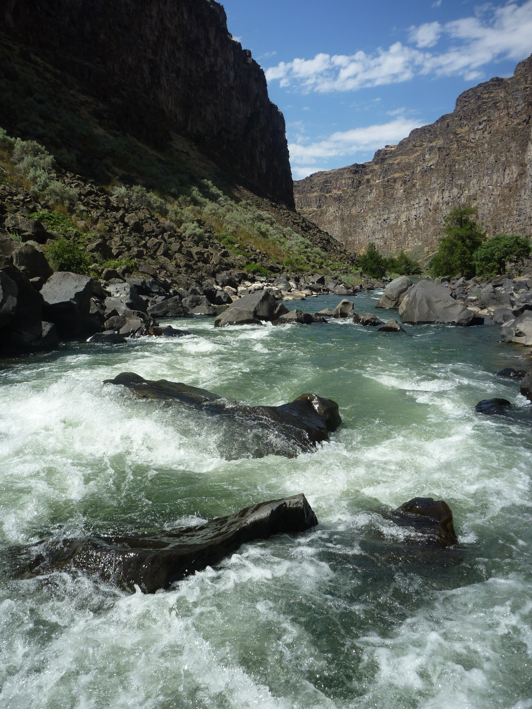

River Ranger Rendezvous
May 29 – June 1 2020
Location: Wild and Scenic Bruneau River Idaho
Sponsored by BLM Bruneau River Program and RMS Northwest Chapter
The 2020 River Ranger Rendezvous will take place on the WSR Bruneau river. The Bruneau River flows north from the Jarbidge Mountains of northern Nevada through the Owyhee Uplands on its way to the Snake River in southern Idaho. Trip length is 41 miles. The Bruneau is a solid class 4 run with the bulk of the whitewater in the last 8 miles. Treat yourself to such rapids as Boneyard, Nemesis and Wild Burro.
First aid and CPR along with a Leave No Trace trainer course will be offer during the trip along with a Swiftwater Rescue scenario to sharpen those dormant rescue skills. Evening topics include What Works for your Program? A chance to highlight the positive impacts of your river program. Notes from a Well-Seasoned Ranger- Tipton Power will share the highs and lows of his nearly 16 years career as a River Ranger in the Owyhee Canyonlands.
For more information and registration contact Evan Worthington (Limit 12 River Rangers) first come first serve. Cost is $25.
Contact info: Evan Worthington 208 384 3329 eworthington@blm.gov

