River Management Society

NW Chapter Owyhee River Trip
April 11-14, 2022

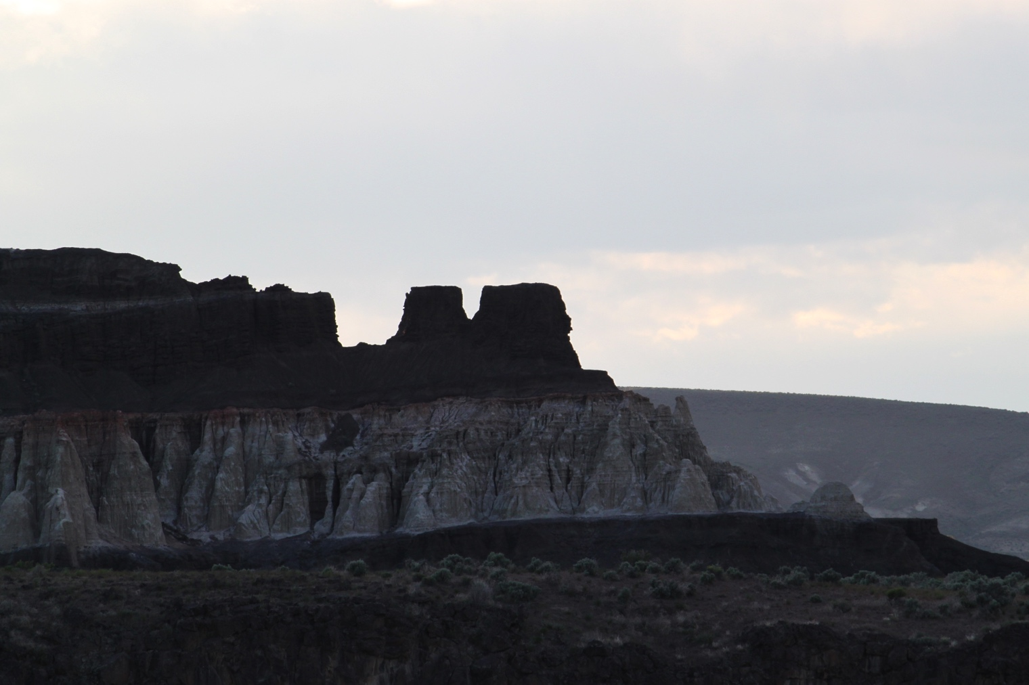

The Northwest Chapter of RMS, in partnership with the BLM Malheur Field Office, is hosting a April river trip on the Owyhee River in South Eastern Oregon.

The Owyhee's headwaters start in Northern Nevada and flows North through Idaho and into South Eastern Oregon. At the Rome launch site the Owyhee is still a free flowing river fed by snowmelt and spring rains. As one travels down into this remote canyon the adventures from the river trip and hiking the canyon will bring lessons of Archeology, Geology, and American history.

The Northwest Chapter trip will launch from the Rome put-in on April 11th and take-out at Birch Creek Historic Ranch on April 14th, for a total trip length of 48 river miles (4 days/3 nights). The river is Class II – III+ pool-drop river. As flows drop the river gets more technical. Rafts, and kayaks are the preferred watercraft for this float. Rafters should be comfortable with Class III+ rapids. Kayakers should have solid Class III+ experience. This is a spring run off so the water is cold. If you don’t have the experience, it’s OK! There will be some open seats on experienced boater’s watercraft. Let us know, and we will do our best to arrange an open seat for you!

Trip Logistics

Registration: Trip sign up is first-come, first-served and is limited to 20 participants (including host staff). No refunds for cancellations. Trip is open to current NW Chapter RMS members at a cost of $65. On the Owyhee, there is always the possibility that flows could drop below raftable conditions, although I don’t anticipate it this year. In the event that it does we would possibly switch rivers or refund the fee.

Registration will be open from now until April 1, 2022. Cost is $65 per person and covers food. (Shuttle not included) Mail this form with a check payable to “ Dan Thomas” to:

Dan Thomas
1997 Graham Blvd.
Vale, OR 97918

The deadline for registration is April 1, 2022 or when the maximum group size of 20 people is met, whichever comes first. A waiting list will be maintained in the event of a cancellation. Please keep in mind that registration fees are non-refundable – be sure of your availability before registering.

Pre-Trip Information: Participants should arrive at the Rome put-in by 8:00 am Mountain Time on Monday, April 11th, the morning of the launch, to prep boats and gear. We will try and launch by 10 am Mountain Time. The ramp can get crowded at times, anyone that can show up to rig boats on Sunday evening would help. There is a free campground at Rome.

Oregon Invasive Species Sticker Requirement - Anyone who wishes to launch their boat in Oregon waters is required to purchase an Oregon Invasive Species license. You can purchase one anywhere you can buy a Oregon fishing license. This license is required to legally launch and operate your boat in Oregon.

Floating Logistics: We will launch on Monday morning, April 11th no later than 10 AM Mountain Time at Rome and spend 4 days and 3 nights on the river, coming off on Thursday afternoon, April 14th at Birch Cr. Packets with more detailed information will be provided to participants (river map, traveling routes, directions, trip information packet).

Meals: Meals from lunch on April 11th through lunch on April 14th will be provided. Breakfast on April 11th and dinner on April 14th are on your own.

Shuttles: Shuttles will not be included in the trip cost. Participants will be responsible for their own shuttle. The cost of a shuttle from Rome to Birch Cr. is around $160/vehicle.

Weather & Gear: Rain, snow or sunshine are all possible in early May and average temperatures can range from 30 to 80 degrees. So please be prepared for a wide range of weather conditions. Confirmed participants will receive a recommended gear list with their trip packet.

Directions:
Rome is approximately 30 miles south of Jordan valley, OR. on Highway 95.

Birch Creek takeout is reached via Highway 95 and Jordan Craters Rd. This site is accessible by four-wheel drive vehicles: The road may be temporarily closed after a heavy rain.

Post Trip Information: We should be off the river by mid-afternoon, Thursday, April 14th. Additional travel information will be sent to participants, including camping and lodging information for those wishing to spend an additional night in the area prior to traveling home.

Additional information on this trip, contact:

Dan Thomas
dthomas@blm.gov
(541) 473-6266

Additional Resources:

The BLM River Guide is sold at the BLM Vale District Office 541-473-3144. You can call and pay with a credit card and they will mail you one. The cost of the river guide is $10 each.

