Wild & Scenic Rivers Program
National Park Service
U.S. Department of the Interior

Partnership Rivers News

Welcome to the Partnership Rivers News
Welcome to the first edition of the Partnership Wild and Scenic Rivers newsletter. We hope to introduce you to the remarkable rivers that bearthe name "Partnership," and to show you how this unique community-based conservation program works.
What exactly is a "Partnership" Wild and Scenic River? The National Wild and Scenic River System has been around in this country for the past 30 some years, created by an act of Congress in 1968. The "Wild and Scenic Rivers Act" calls on the nation to preserve select rivers with outstanding scenic, recreational, geologic, fish and wildlife, historic, cultural or other important values in free-flowing condition. Rivers in this national system are protected for the benefit and enjoyment of present and future generations.
Partnership Wild and Scenic Rivers are a subset of this national system. While most of the 160 rivers in the National Wild and Scenic Rivers System flow through federal lands such as National Forests or National Parks, Partnership rivers flow through private lands and lands owned by local or state governments. The seven rivers currently established as Partnership National Wild and Scenic Rivers are located in the Northeast, though the program is national and has recently named its first river in the southeast. The established rivers include the Farmington (Connecticut), Great Egg Harbor (New Jersey), Maurice and tributaries (New Jersey), Lamprey (New Hampshire), Sudbury, Assabet, and Concord Rivers (Massachusetts), the recently designated Lower Delaware (New Jersey/Pennsylvania), and White Clay Creek (Delaware/Pennsylvania).
Since 1998, Congress has appropriated funds for river managers on each of these seven Partnership rivers. National Park Service staff help communities manage their river-related resources locally by bringing together state, county, and community representatives to preserve the outstanding and remarkable values for which the rivers were designated. This is community-based conservation that will ensure these rivers will remain outstanding long into the future.
The program is branching out to the southeast with the addition of the Wekiva River and two of its tributaries in Central Florida. In October 2000, Congress officially named 67 miles of the Wekiva River to the program. Now local leaders are drafting management plans and working with Park Service staff to build local partnerships to protect the crystal clear waters and natural shorelines of the Wekiva.
With increased funding from Congress, the Park Service will be able to build a long-term community partnership on the Wekiva and to sustain the important work of preserving the other outstanding rivers in the Partnership Wild and Scenic Rivers program.
For more information on Partnership Wild and Scenic Rivers, please see our website at www.nps.gov/pwsr.
Charlie Stockman,
Program Manager

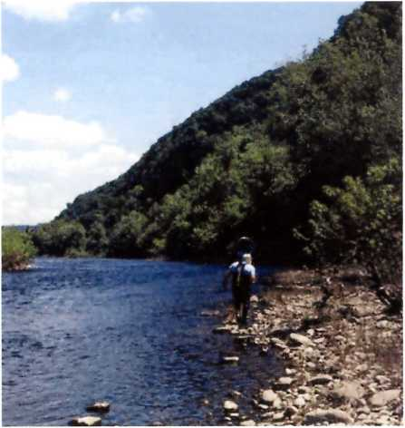
1 The great fisheries in the Lower Delaware River attract anglers and support a wide array of wildlife in this heavily populated area.

Lower Delaware River’s designation
inspires local protection efforts
If you have only seen the Delaware River through the window of a car, you might be surprised to learn that this river is a Wild & Scenic River. The river offers a beautiful background for most of the views from the roads that run alongside, but it does not look very natural—much less wild—from an automobile.
The view from the river, however, is quite different. Water and trees dominate the landscape. When you are out on this lovely, quiet river, it is hard to believe that the homes, offices and shops of 20 million people are within a few hours drive. The man-made world seems far away.
The Upper Delaware, consisting of the 78 miles between Hancock, New York, and the Delaware River Water Gap, entered the Wild & Scenic program in 1978. Soon after, a proposed dam on other free-flowing portions of the river prompted Congress to designate 37 miles along the Middle Delaware, which flows through the Delaware Water Gap National Recreation Area and is managed as a unit of the National Park Service.
Some 22 years later, a plan to pump 100 million gallons of water a day from the lower reaches of the river spurred the Delaware River Greenway Partnership to seek designation for the Lower Delaware as a Partnership Wild & Scenic River. Congress passed the designation in November 2000.
Wild & Scenic status has raised public consciousness of the national importance of the river and improved communication among the Lower Delaware River communities. The Lower Delaware River study and its designation have inspired a number of local efforts to protect the natural, historic, scenic and recreational resources that made the river eligible for designation. For instance, largely as a result of the Study process, the state acquired Hendrick Island, a natural oasis of more than 100 acres in Solebury Township, and designated several other state-owned islands as a Pennsylvania Natural Area.
Since designation, a committee has formed to oversee implementation of the goals in the management plan written by state and local officials, businesses, and citizens, and the river corridor is alive with activity. The committee and the Greenway Partnership are conducting a stream corridor restoration project, preparing open space and recreation plans, and developing a landowner stewardship program.
Of particular importance, the interstate Delaware River Basin Commission has formed a committee of water quality experts to oversee a five-year study of the water quality in the Lower Delaware. The Commission is also considering awarding “Special Protection Waters” status to the Lower Delaware. This status is an important step in providing even more protection to the river’s water quality, which is one of the resources for which it received designation.
The committee will be awarding municipal incentive grants the summer of 2002 to encourage action at the local level. “The municipal incentive grants program is a great way to get the municipalities to actively participate in implementing the River Management Plan” says Jim Amon, chairman of the Management Committee “It helps us demonstrate why designation of the river is a good thing."

Lower Delaware River
67.3 miles flowing from Lower Mount Bethel, Pennsylvania and Harmony, New Jersey to Makefield, Pennsylvania and Ewing, New Jersey
Designated in 2000

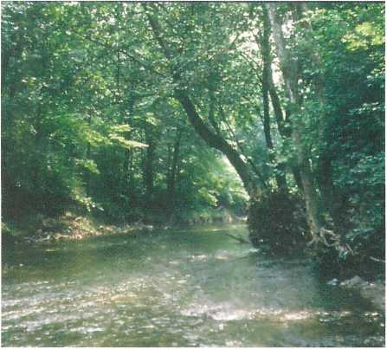
2 The White Clay Creek management committee's activities will focus on improving water quality through education and outreach projects.

White Clay Creek plan focuses on stewardship
Watershed stewardship and education will be two of the top priorities for the White Clay Creek Watershed Management Committee (WMC) as it proceeds with plans to implement the designation of the White Clay Creek as a national Wild and Scenic River.
WMC is responsible for assisting the National Park Service in implementing the Watershed
Management Plan adopted in September 2001, during the river’s designation process.
This year the WMC will work on several projects that seek to improve the quality of the White Clay Creek through education and outreach activities. These projects include:
- posting watershed signs identifying White Clay Creek as a national Wild and Scenic River
- working with local landowners to inform them of existing conservation easement programs, and
- developing a newsletter, and possibly a website.
In all of these activities the WMC will seek to educate the general public about the important historical, geological, and biological features of the White Clay Creek and ways to help protect them.
Other projects that WMC will begin this year include identifying and mapping critical wildlife habitat and developing a comprehensive recreational trail guide.
The 30 official members of the WMC—comprised of representatives of all levels of government, various interest groups and local residents—will work cooperatively to accomplish these projects. In most cases, funding from the National Park Service and other sources will pay for the projects.

White Clay Creek
190 miles flowing from West Marlborough, Pennsylvania to Newcastle County, Delaware
Designated in 2000

Congress adds Taunton and Eightmile Rivers to program
Each of the last two sessions of Congress has authorized new Wild and Scenic River Studies, the first step in designating rivers for this special recognition and protection. The Park Service's Boston Support Office is managing the initial studies for the Taunton River in Southeastern Massachusetts and the Eightmile River in Connecticut.
The Taunton River Study is well underway and boasts its own web site where the public can learn about the river, the study, and the study participants; check it out at www. tauntonriver.org. The Taunton study is the first to use a web site as a major component of outreach and communication efforts. Visit the site and send us your comments about the Taunton and the web site itself.
The newest Wild and Scenic River Study is on the Eightmile River in Connecticut. The Nature Conservancy highlighted the Eightmile in its "Last Great Places" campaign for its remarkable natural qualities. It is a trout fishery of statewide renown, home to endangered species, and a splendid example of a New England small-town landscape preserved. The Eightmile watershed is a tributary of the lower Connecticut River estuary. To learn more about this study, contact Jamie Fosburgh (jamie_fosburgh@nps.gov) or Nathan Frohling of The Nature Conservancy at nfrohling@tnc.org.

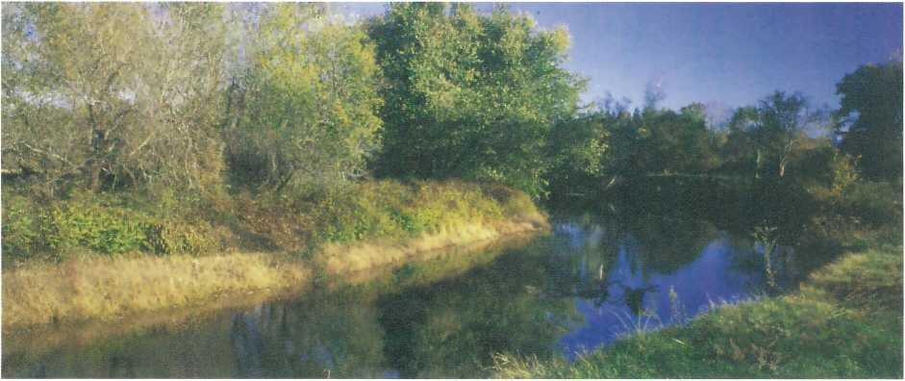
3 This farm is protected forever as open space by a conservation easement from owner Charlie Brady to the town of Lee.

Lamprey River group and landowners team up to protect river’s scenic qualities

Although it flows through coastal New Hampshire towns that have experienced tremendous development over the past five years, the Lamprey River remains a surprisingly scenic river where evidence of 20th century life is the exception. To maintain the river’s natural character, the citizens’ group responsible for implementing its Lamprey River Management Plan has made permanent land conservation its top priority.
In partnership with local communities, land trusts, and state agencies, the Lamprey River Advisory Committee has worked with nine landowners to protect 755 acres and more than 5 miles of frontage on the Lamprey since 1999. Federal funds designated for wetlands protection, the national estuaries research reserve, and Lamprey River protection have leveraged more than $500,000 in municipal and private dollars.
To stretch funding and encourage gifts of land and sales at less than fair market value, the Lamprey Committee created a Landowner Assistance Fund. This Fund covers a landowner’s out-of-pocket costs for surveys, appraisals, and other land transaction requirements when the landowner is interested in donating all or some of the land’s value. The National Fish & Wildlife Foundation provided start-up funding for this program. To date, Lamprey River landowners have donated $523,000 of property value through bargain sales.
“We knew soon after moving here in 1968 that we wanted to keep the property in its natural state, if at all possible, and to allow others to enjoy it as well,” said landowners Paul and Fran Verrette. “Our motivation certainly was not to thwart growth but to preserve a variety of habitats as well as extensive frontage on the river in the hope of providing an informal recreational and learning environment unspoiled, and in perpetuity.”
The Lamprey Committee and Town of Lee were able to help the Verrettes realize their long-standing dream. By purchasing conservation easements, accepting donations, and purchasing land outright, the Lamprey conservation efforts have protected farmland, wetland and river habitats for the largest populations of regionally rare Blandings and Wood turtles known to be on the river, and forested riparian and upland habitats.

Lamprey River
23.5 miles flowing from Epping to Newmarket, New Hampshire
Designated in 1996

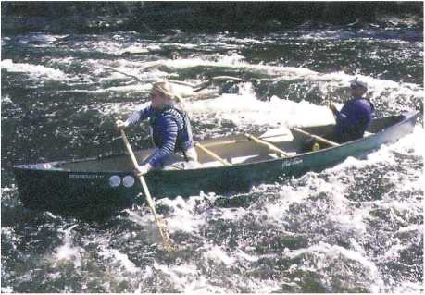
4 Spring highwater gives boaters a wild ride.

School program builds interest in Great Egg Harbor River
Education has been a centerpiece on the Great Egg Harbor Wild and Scenic River since the beginning. It was the Great Egg Harbor Watershed Association, an educational non-profit organization, that sought designation for the Great Egg Harbor River, and it has continued to provide a focus on education, outreach and advocacy.
The Watershed Association’s latest project, an adopt-a-stream program, is bringing school children to the water’s edge and raising awareness and interest across a broad spectrum of Atlantic County, New Jersey. With assistance from the National Park Service, the Watershed Association established the adopt-a-stream program for middle- and high-schoolers in Egg Harbor Township and taught teachers how to sample water quality on the muddy bottom stream.
The Watershed Association created field workbooks based on the streamside biosurvey developed by the Izaak Walton League of America to guide teachers’ lectures and stream sampling. Together, the Watershed Association and the teachers developed guidebooks for students as well. The schools reported their water quality findings to
the N.J. Department of the Environment for use in assessing streams within the Great Egg Harbor River and Watershed.
The students didn’t stop there, however. They’ve turned their program into a highly successful outreach tool by also reporting their findings and an evaluation of the Adopt- A-Stream program to locally elected officials to gain continued support for the program. The students also broadcast their presentations on the local cable channel, using video clips of their field work and interviews, to promote environmental awareness about the river and the watershed. The schools plan to make their program available to all schools in the county by sharing their videos over the Atlantic County Library's distance learning program via direct T3 Internet connections. Student and teacher enthusiasm for the program has helped it grow.
In 2000, Atlantic County supported the program with a watershed management grant, enabling it to expand into Hamilton Township Middle School. It has been an excellent awareness tool to educate students, teachers and locally elected officials about the importance of protecting rivers and streams in their area.
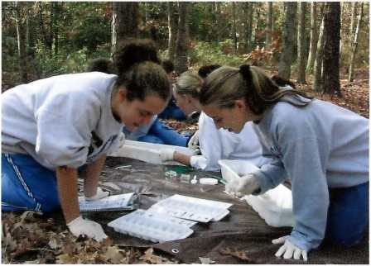
5 Student studies of water quality have raised awareness about the Great Egg Harbor River

Great Egg Harbor River
129 miles flowing from Winslow Township to Upper Township, New Jersey
Designated in 1992
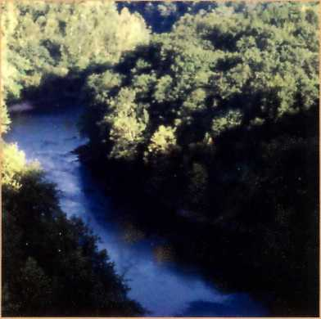
6 What is the economic value of the clean water, healthy fish and wildlife, recreation opportunities and other assets of conserved rivers?

Study assesses economic impact of Farmington River
What is the value of a conserved river? To help answer that question, the National Park Service and American Rivers have selected the Wild and Scenic Farmington River as the focus of a one-year study to evaluate whether healthy rivers are good for the economy as well as for people and wildlife. Roger Moore and Christos Siderelis of North Carolina State University are designing and directing the study, which will measure the direct and indirect economic impacts of the Wild and Scenic Farmington River on surrounding communities. The study will help inform local landowners, business owners, and decision-makers about the economic impacts of protecting the river. It should also serve as a model for communities across the nation that want to thoroughly consider the economic value of river protection.
Researchers will gather empirical data on how much money recreationists spend along the Farmington River corridor during one season, and how those expenditures directly and indirectly affect the local economy. Dr. Moore will be organizing surveys of river users over a full river recreation season, using both personal interviews and mailed questionnaires. The study will also evaluate land values along the river. The results of the survey are expected out later this year.

Farmington (West Branch)
14 miles flowing from Hartland to Canton, Connecticut
Designated in 1994
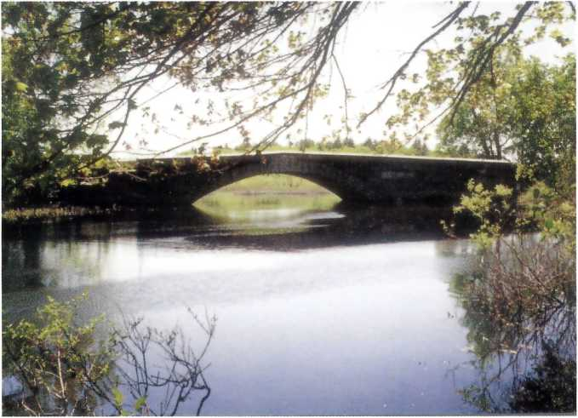
7 Designation of the Concord-Sudbury-Assabet River system as a Wild & Scenic River provided the perfect committee structure to take action when historic Lee Bridge needed conserving.

A bridge to the past: Preserving history and sense of place along the Concord, Sudbury, and Assabet Rivers
In historic Lincoln, Massachusetts, a Partnership river group has collaborated with state and local officials to preserve a bridge that is both a piece of the river’s past and a cherished landmark in this rural town.
Lee’s Bridge, an historic relic crossing the Sudbury River—which is one leg of the Sudbury, Assabet, and Concord Wild & Scenic River—bore the town’s history well, but could not sustain the heavy loads of modern traffic on a major commuting route outside Boston. Descendants of John Adams had donated the original bridge to the towns of Concord and Lincoln, and Thoreau referred to it in his writings. But in October 1999, a 25-by-15-foot hole in the bridge stopped traffic and threatened to eliminate the bridge altogether.
Fortunately, the Sudbury, Assabet and Concord rivers had achieved Wild and Scenic status in June, and the newly formed River Stewardship Council was ready to take on the challenge of preserving Lee’s Bridge. The council—a forum for protecting the three rivers’ outstanding resources—proved an ideal body to address the bridge issue because it includes representatives from the towns of Concord and Lincoln, as well as the Great Meadows National Wildlife Refuge, which owns land adjacent to the bridge.
The Stewardship Council and the towns asked the Massachusetts Highway Department to rebuild the original 1912, two-span, granite-masonry bridge with historical accuracy. The highway department agreed to work closely and expeditiously with the towns and the Stewardship Council to rebuild the bridge from its original granite stonework.
“This bridge helps define the character of our community and maintaining its historical integrity is something everyone wants,” said John Kerr, Lincoln selectman and the town’s representative to the River Stewardship Council. “The Wild and Scenic designation lent strong support to our negotiations with the highway department. I don't know if we would have been as successful without it."
With concerted effort from all involved, the highway department expedited public hearings and initial planning, and completed all its design work in less than two years. The Stewardship Council reviewed all design plans to ensure historic integrity; members worked with their town officials, kept the council informed, and developed relationships that helped move the project forward. Because of the Wild and Scenic designation, Park Service staff were able to lend their expertise to the project.
With the project about to be put out for bid, the Stewardship Council is staying focused on completing the bridge reconstruction. Looming state budget cuts and personnel changes in the highway department may throw roadblocks in the way, but the Council is in a good position to make sure that history is repeated when Lee Bridge is rebuilt.
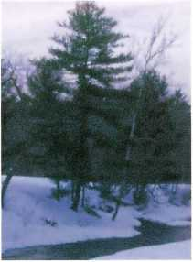
“This bridge helps define the character of our community and maintaining its historical integrity is something everyone wants.”
—John Kerr, Lincoln selectman and the town’s representative to the River Stewardship Council

Sudbury, Assabet, Concord Rivers
29 miles flowing from Framingham to Billerica, Massachusetts
Designated in 1999

Maurice River partners scope sites for nature center on migratory bird flyway
Capitalizing on a 1994 Nature Center Concept Plan, the National Park Service and Cumberland County, New Jersey, are assessing potential sites for a proposed nature center along the Maurice Scenic & Recreational River. The Maurice offers ideal conditions for a nature center, including its role as an important part of the Atlantic flyway for migrating birds. It also provides numerous pristine habitats that support endangered species. The 35.4-mile Maurice River system begins in southern New Jersey and drains the southwest portion of the Pinelands National Reserve, linking the Reserve and Delaware River estuary.
The Nature Center would interpret the cultural and natural resources of the Maurice River and serve as a river access point for visitors. The river’s comprehensive management plan, completed by the Park Service and its river partners in January 2001, suggests key ecological themes around which the Nature Center could develop interpretive programs and materials.
The Park Service is helping to fund the feasibility study with a $30,000 allocation. The study will assess existing structures along the river to see if any have the right combination of location and architecture to house a nature center.
The idea of a nature center along the lush Maurice River has attracted the attention of the New Jersey Marine Sciences Consortium and the N.J. Department of Fish, Game & Wildlife, creating additional opportunities to bring new partners into the nature center concept and planning process.
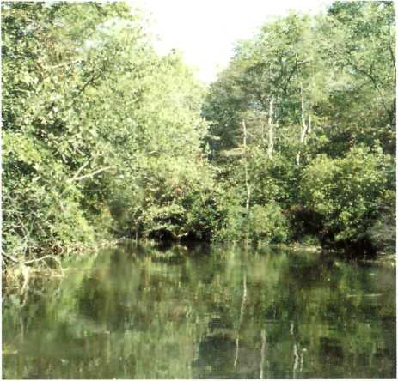
8 The lush Maurice River is an important stop on the Atlantic flyway for migrating birds, making it an ideal location for a nature center.
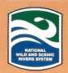 Wild & Scenic Rivers—Partnership Program

Contact Information
Farmington River
Farmington River Coordinating Committee
www.nps.gov/rivers/rivers/farmington/toc.html
NPS contact: Liz_Mikulecky@nps.gov
860-379-0282
Lamprey River
Lamprey River Advisory Committee
www.lampreyriver.org
NPS contact: Margaret_Watkins@nps.gov
603-226-3240
Maurice River
Citizens United
www.cumauriceriver.org/pages/maurice.html
NPS contact: Paul_Kenney@nps.gov
215-597-5823
Wekiva River
NPS contact: Stephen_Bowes@nps.gov
941-330-0069
Great Egg Harbor River
The Great Egg Harbor Watershed Association
www.greategg.org
NPS contact: Mary_Vavra@nps.gov
215-597-9175
Lower Delaware River
The Delaware River Basin Commission
www.state.nj.us/drbc/wild_scenic.htm
NPS contact: Bill_Sharp@nps.gov
215-597-1655
Sudbury, Assabet, and Concord Rivers
Massachusetts River Team
www.state.ma.us/envir/mwi/suasco.htm
NPS contact: Lee_Steppacher@nps.gov
617-223-5225
White Clay Creek
The White Clay Creek Watershed Association
mercury.ccil.org/~wcwa/
NPS contact: Chuck_Barscz@nps.gov
215-597-6482

Helping communities preserve and manage their own rivers in the National Wild and Scenic Rivers System.

National Park Service U.S. Department of the Interior
Partnership Rivers News is published by the Partnership Rivers in the Wild & Scenic Rivers Program.

Editor
Margaret Watkins

Program Manager
Charlie Stockman

Contributors
Chuck Barscz Jamie Fosburgh Paul Kenney Liz Mikulecky Bill Sharp Lee Steppacher Mary Vavra

Photographers
James Amon Chuck Barsca Julia Blatt, Organization for the Assabet River Paul Kenney Jerry & Marcy Monkman/ EcoPhotography.com Gregg Vizzi White Clay Watershed Association

Designer
Kelly Short, Canterbury Communications

Comments? Contact:
Charlie Stockman National Park Service 1849 C Street, NW Washington, DC 20240

Phone
202-565-1189

E-mail
Charlie_Stockman@nps.gov

For more information:
www.nps.gov/pwsr

EXPERIENCE YOUR AMERICA
The National Park Service cares for the special places saved by the American people so that all may experience our heritage.

