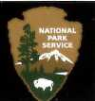 National Wild & Scenic Rivers Program

National Park Service

U.S. Department of the Interior

Partnership Rivers News

Original Newsletter Published:

Accessible Version Created: October 29, 2020

A better solution: Hard work and collaboration

Welcome to the third issue of Partnership Rivers News, a newsletter designed to let you know a little bit more about the special "Partnership Rivers" in the National Wild and Scenic Rivers System. The eight rivers currently in the system—seven in the Northeast and the Wekiva in central Florida—are managed through a partnership of federal, state, and local agencies, local folks and non-profit groups, and the National Park Service. In this issue you will learn about creative ways river councils, management and advisory committees, and watershed groups work with government agency staff to meet the protection challenges facing their rivers.

The Wild and Scenic River Program may still be best known for the more remote rivers that flow through truly wild and unfamiliar places, but many of the rivers in the program bring their scenic qualities and special characteristics right to our doors, flowing through towns, farms, and countrysides familiar to most of us. The eight Partnership Rivers belong to the latter group, and while they are familiar to us and deliver many benefits, they also face the mounting pressures of population growth and the resulting development that follows. These are the challenges that non-profits, individuals, and agencies at all levels band together to address through the Partnership Rivers program.

The issues described in this newsletter are myriad: wastewater discharges and non-point source pollution; increased recreational demands, historic preservation and park development; threatened and endangered species protection and streambank restoration. In each case, management partners gathered around the issues and worked together toward solutions. While tackling these issues took time and patience, hard work and many volunteer hours, collaboration resulted in better solutions and healthier rivers than any one organization could have provided.

For more information on Partnership Wild and Scenic Rivers, please see our website at www.nps.gov/pwsr.

Charlie Stockman,
Program Manager

Bridge redesign improves road and benefits threatened bog turtle

On Lamborn Run, a tributary of the Wild and Scenic White Clay Creek, collaboration between Wild and Scenic partners and the Delaware Department of Transportation (DOT) has resulted in a bridge reconstruction project that solved a serious road hazard and improved habitat for a bog turtle that is on the federal list of threatened species.

The erosive forces of Lamborn Run were undermining the stability of a bridge and a road in New Castle County, Delaware, so the DOT proposed to realign the stream channel and replace the existing bridge with a new, three- sided, pre-cast concrete bridge. While the bridge itself met most of the design guidelines of White Clay Creek’s watershed management plan, plans for stabilizing the bridge raised concerns about potential negative impacts on Clemmys muhlenbergii, a threatened bog turtle that uses Lamborn Run as a migratory corridor.

Since the bog turtle is one of the outstandingly remarkable values that led to White Clay Creek’s Wild and Scenic designation, the National Park Service and the White Clay Watershed Management Committee joined in the project to help the DOT and other state agencies meet the state’s transportation needs while protecting the turtle and other watershed resources.

The original engineering plan called for using rip-rap, or stone, under the bridge and around its wing-walls and footers to prevent bank erosion and scouring. Rip-rap, however, is a known hazard for bog turtles and other small amphibians and reptiles because they tend to get trapped in the gaps between the stabilizing rocks.

The Park Service and the Endangered Species Program of the state’s natural resources and environmental department advocated filling the gaps in the rip-rap to mimic natural stream conditions and covering the side slopes with topsoil and grass. As a result, the DOT revised its plans and created a low-flow channel and filled gaps in the rip-rap with stream gravel and stone that had been displaced during the bridge construction.

They covered the rip- rapped side slopes with topsoil after the gaps were filled, and planted the area with grasses and willow trees. The vegetation on these side slopes has created a safe migratory corridor for the bog turtles, improved overall habitat value of the riparian area, and improved aesthetics. With these changes the Park Service determined that the project would not have an adverse impact on the bog turtles.

This project demonstrated to state transportation engineers and contractors that rip-rap can be covered without compromising the structure of the bridge and without causing significant cost overruns. It also showed that the added aesthetic and habitat value were worth the additional time it took to cover the rip-rap.
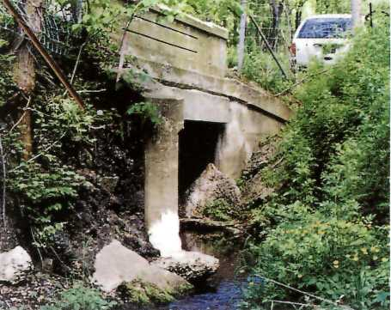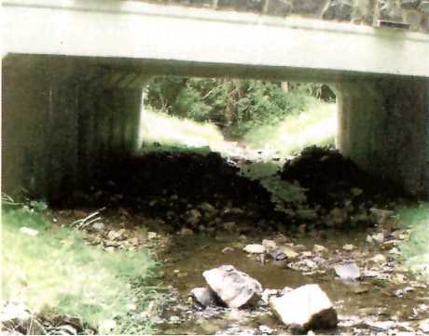
1 Repair of a crumbling bridge on Lamborn Run improved road safety and provided better habitat for a threatened species of turtle.

White Clay Creek
190 miles flowing from West Marlborough, Pennsylvania to Newcastle County, Delaware Designated in 2000

Wiswall Park celebrates Lamprey’s history
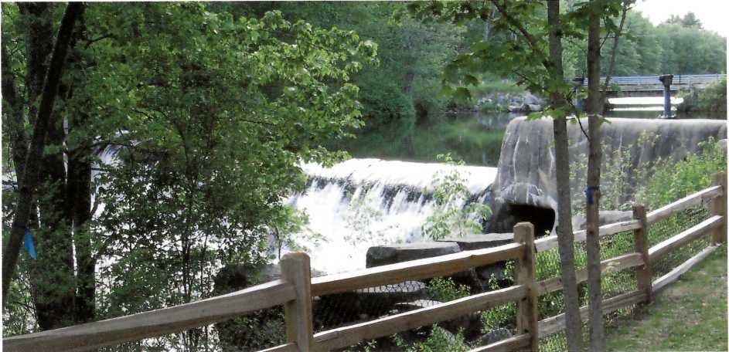
2 New riverside park tells the 8,000-year history of human use of the rapids.

People have used the Lamprey River in southern New Hampshire for thousands of years, as a source of food, water, and power, as a corridor to interior forests, and as a recreational resource. Much of this history is documented at a small site in Durham that the town now owns. Cooperatively with the Lamprey River Advisory Committee (LRAC), the National Park Service, and others, the town is developing a riverside park to highlight the river’s uses, past and present.

The story being told at the Wiswall Park begins some 8,000 years ago, when Native Americans were drawn to the rapids to fish. Centuries later those same rapids attracted early colonists, although no dams were built at the site until 1835. Thereafter, commerce boomed and Wiswall Mills were the center of Durham’s industrial life by the mid-1800s. Remains of structures from this period include the power canal, sawmill, paper mill and its hydroelectric plant, boiler room, a shed, stockhouse, three unidentified structures, and a crib dam. The property has been recognized on the National Register of Historic Places for its “considerable potential to
inform us about the organization of a small paper mill and the hydraulic relationship of three competing mills.”

Today, the site is again a community focus with numerous groups working together to create a park that honors the site’s history and commemorates John Hatch, an artist, historian, conservationist, and LRAC volunteer. Collaborators include the LRAC, the Town of Durham, the National Park Service, the town Recreation Committee, Boy Scouts, and neighbors.

The LRAC, the citizens group established under the auspices of the Wild & Scenic Rivers Program and the state rivers protection program, and the National Park Service commissioned a mason skilled in historic preservation to rebuild the stone wall along the power canal. Park Service planners sketched preliminary park designs, which both the Town Council and neighbors reviewed. The town Recreation Committee cleared a canoe launch and path, while the Durham Public Works Department created a gravel parking lot and built a platform overlooking the canal. An Eagle Scout created a plaque describing the site’s significance, and the LRAC paid for fencing, which the town installed. In addition, a number of federal, state, and local partners are working to develop fish passage around the dam.

Once completed, the site will offer students a lovely setting in which to learn about New England history and the role rivers played in it. Picnickers, canoeists, and other visitors also will have access to this piece of river history.

Lamprey River
23.5 miles flowing from Epping to Newmarket, New Hampshire
Designated in 1996

Local partners protect 271 acres along the Great Egg Harbor River corridor

A quick response and cooperation among Wild and Scenic partners managing the Great Egg Harbor River have protected 271 acres within and adjacent to the federally designated river corridor and its designated tributary, Miry Run. The property includes significant wetlands and other important habitats along the river.

“This property is significant to our efforts to protect the Great Egg Harbor River,” said Dennis Levinson, the Atlantic County Executive. “Under existing zoning, as many as 25 homes could have been built on the property’s upland area. Instead, it will now be protected and preserved to enhance the quality of life of our residents and visitors, as well as future generations.”

In early 2001, a group of local residents formed to oppose a proposal from the Egg Harbor Township Police Athletic League, which wanted to create a 1,000-acre All Terrain Vehicle (ATV) facility for this undeveloped area.

Concerned about potential negative impacts on the federally designated river corridor, the residents contacted the Great Egg Harbor Watershed Association and the Great Egg Harbor River Council for assistance. Egg Harbor Township was involved also through its seat on the Council as a Partner Municipality in the Wild & Scenic Rivers Program.

The residents’ primary concerns included noise, air quality, water quality, property damage, and offsite traffic impacts. Atlantic County, which owns considerable public recreational land adjacent to the proposed ATV facility, including a golf course, was concerned about public liability issues. Egg Harbor Township indicated that it did not want additional residential development in this area.

The Great Egg Harbor River Administrator undertook a characterization and assessment of the outstanding natural resource values at the proposed site and determined that the lands involved included significant wetlands, fragile Pinelands sandy soils, and threatened and endangered species.

Atlantic County decided to acquire as much of the critical watershed lands involved as possible for permanent protection, and announced acquisition of the 271-acre Polakoff property in June 2004. The county funded the $301,500 purchase with state Green Acres grants and money from the Atlantic County Open Space Trust Fund, which it had previously established for open space acquisition.

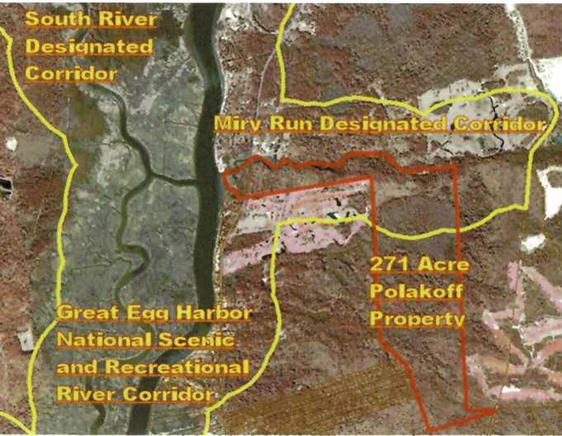
3 The 271-acre Polakoff property, outlined in red, was protected in June 2004.
“Under existing zoning, as many as 25 homes could have been built on the property’s upland area. Instead, it will now be protected and preserved to enhance the quality of life of our residents and visitors, as well as future generations.”
—Dennis Levinson,
Atlantic County Executive

Great Egg Harbor River
129 miles flowing from Winslow Township to Upper Township,
New Jersey Designated in 1992

Assabet River partners battle against low water quality standards on historic river

The scenic, historic Assabet River was a favorite of Hawthorne and Thoreau. Unfortunately, however, this Massachusetts Wild and Scenic River now fails to meet state water quality standards. Excess nutrients entering this slow-moving river from four municipal wastewater facilities cause severe eutrophication, and in the summer, a thick mat of green plants and algae blankets sections of the river, impairing recreational use and making it difficult for fish to breathe.

The Organization for the Assabet River (OAR), a non-profit, has been working with regulatory agencies and municipalities for years to improve the river’s water quality through science-based advocacy. Since the river earned Wild & Scenic designation, OAR has found a new ally in the Sudbury, Assabet, and Concord Wild and Scenic River Stewardship Council (RSC), the organization created to help manage the river under the Wild and Scenic Rivers Program. The RSC has provided critical funding and support for OAR’s work on the problem of eutrophication, and has also weighed in publicly in support of the river. This work is beginning to pay off.

The permits that govern operation of the wastewater treatment plants are jointly issued by the state and federal environmental agencies every five years and must enable the river to meet water quality standards. A three-year study of the Assabet River found that if no other actions were taken to improve the river, phosphorus limits for the wastewater treatment plants might need to be as low as 0.024 milligrams per liter (mg/L) to achieve water quality standards (phosphorus discharge limits are currently 0.75 mg/L for each of the four facilities).

Due to the high cost to municipalities of meeting very low phosphorus limits, the agencies settled on a phased-in approach, starting with a somewhat higher phosphorus limit of 0.1 mg/L. Compliance with this new limit is expected to result in substantial improvement to the river, although this action alone won’t allow the Assabet to meet water quality standards.

The agencies also directed the municipalities to study the feasibility of sediment remediation and dam removal to identify possible alternatives for removing phosphorus from the river. If no feasible alternative is identified, the communities should expect to be required to meet lower permit limits in five years.

However, if study recommendations can be implemented, the communities may be able to save money on future wastewater treatment plant upgrades, and stream improvements could help restore the river to health. The study began in January 2005, supported by $500,000 in state funding secured last fall by OAR and the municipalities with sewer systems.

Wild and Scenic designation has created greater opportunities for protecting the Assabet river by fostering cooperation and complementary efforts of key organizations and communities. The RSC and the National Park Service have joined OAR in advocating to protect the outstandingly remarkable values for which the river was nominated into the National Rivers System. Today, the Assabet’s future looks brighter than it has in years.

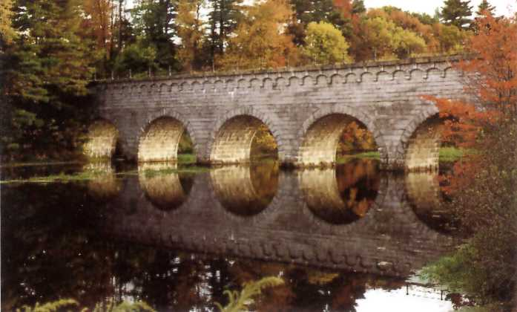
4 The beautiful and historic Assabet River in fall (above) and during the heat of summer (below), when excess nutrients from wastewater treatment plants fuel an explosion of algae and plants.
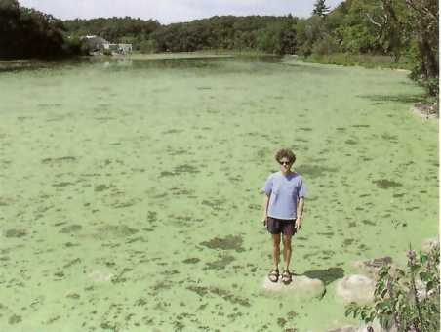

Sudbury, Assabet,
Concord Rivers 29 miles flowing from Framingham to Billerica, Massachusetts
Designated in 1999

Maurice River: Land trust protects 370 aces
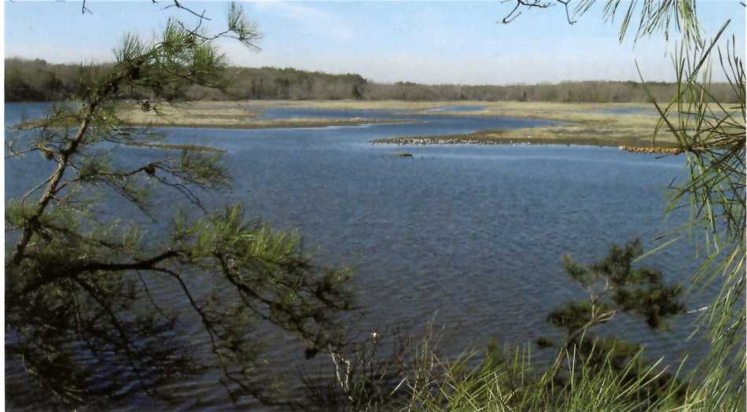
5 The recently protected Maurice River Bluffs—variously threatened by excavation, development, and transportation projects.

Capping off a nearly 15-year conservation effort, The Nature Conservancy in January 2004 purchased 370 acres of riverside land along New Jersey’s Wild and Scenic Maurice River. Coupled with a series of other Conservancy land purchases south of this parcel since 2000, the recent purchase will stretch the protected area of the river’s west bank to more than three miles. The New Jersey Green Acres Program facilitated the land sale.

Nearly all the recently purchased land along the Maurice is undeveloped upland, known locally as the Maurice River Bluffs. Through conservation ownership, the pristine riparian corridor’s future is now secure, but this was not always the case. Gravel and sand excavation, a housing development, a river port, and a bridge crossing have all been proposed along the bluffs of the Maurice River.

This series of threats to the Maurice River Bluffs was a key reason environmental organizations such as Citizens United To Protect the Maurice River moved to have the river studied for inclusion in the National Wild and Scenic Rivers System in the mid-1980s. In fact, local, county, and federal participants identified the Maurice River Bluffs as a critical area for focusing protection efforts in the river’s initial comprehensive management plan.

The National Park Service currently manages a cooperative agreement with The Nature Conservancy and, consistent with the management plan, is participating in a public planning process to explore opportunities for recreation and access to the property and river. The Conservancy will inventory the property first, and the Park Service will be a key partner in that effort.
For more information on the Maurice River Bluffs purchase, please contact Bob Allen at the Conservancy, Rallen@TNC.org, or the Park Service’s Paul Kenney at Paul_Kenney@nps.gov.

Maurice River
35.4 miles flowing from Millville to Delaware Bay, New Jersey
Designated in 1993

Stream restoration project brings Lower Delaware community together
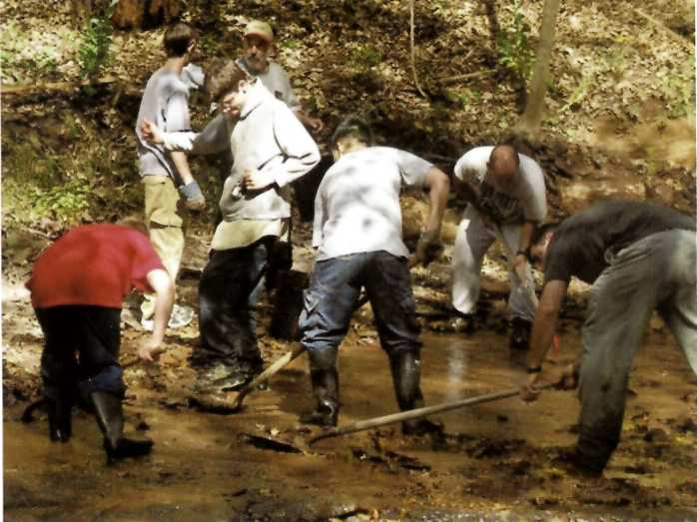
6 Youth groups, local businesses, state agencies, and organizations helped the Lower Delaware Wild and Scenic Management Committee, Tinicum Creek Watershed Association, and Tinicum Township to restore Heaney's Run.

River restoration projects often bring community organizations together and help them focus on the challenges a river and its ecosystem face. Not only do participants learn about the river, they also develop lasting organizational relationships. One such recent river restoration on the Lower Delaware National Wild and Scenic River involved Heaney’s Run, a tributary to Tinicum Creek, a designated segment of the Lower Delaware.

Heaney’s Run is a high quality stream designated as “exceptional value waters” by the State of Pennsylvania. In 1999, however, hurricane Floyd dammed Heaney’s Run with two large trees, ripped out the banks for several hundred feet, and deposited tons of rock debris and silt on its blue shale riffle- and-run creek bed. Overbrowsing deer exacerbated damage to the river’s banks and, to make matters worse, positive fecal coliform bacteria counts were observed in Heaney’s Run’s otherwise excellent waters.

The Tinicum Creek Watershed Association initiated the Heaney’s Run Pollution Control and Streambank Restoration project to identify the source of the coliform pollution, open the natural stream channel, and restore riparian vegetation in the most heavily damaged reach. Participants also took advantage of the great opportunity created by the project for teaching about the river and its environs.

Local help came from a Boy Scout Troop, a high school environmental club, and a plant nursery, as well as the Delaware Canal State Park, the Delaware River Greenway Partnership, Forbes Environmental Consultants, the Lower Delaware Wild and Scenic Management Committee, and Tinicum Township, which all joined forces to restore Heaney’s Run. The Lower Delaware Wild and Scenic Management Committee supported the project with a $4,000 grant from its Municipal Incentive Grant Program, and Tinicum Township matched the grant.

Over two days, teams removed debris from the stream channel, installed bio-logs and coir blankets to stabilize the banks, collected stream samples every 100 yards to test for coliform, and planted trees and shrubs in the riparian zone to stabilize the area and improve habitat.

Working together, the partners achieved multiple objectives. The project identified wildlife as the source of the coliform bacteria. The new plant materials, which survived a couple of heavy downpours shortly after installation, are thriving after one year and stabilizing the banks. Project partners from Tinicum, the state park, and Forbes Environmental created a seminar that teaches the requirements for the Boy Scouts’ Soil and Conservation Badge and can be used with other restoration projects.

The project won a State of Pennsylvania Environmental Council award and has spawned three other stream restoration projects in the area, one of which is seeking another Municipal Incentive Grant.

Lower Delaware River
67.3 miles flowing from Lower Mount Bethel, Pennsylvania and Harmony, New Jersey to Makefield, Pennsylvania and Ewing,
New Jersey Designated in 2000

Farmington River: Pipeline project presents stewardship opportunity
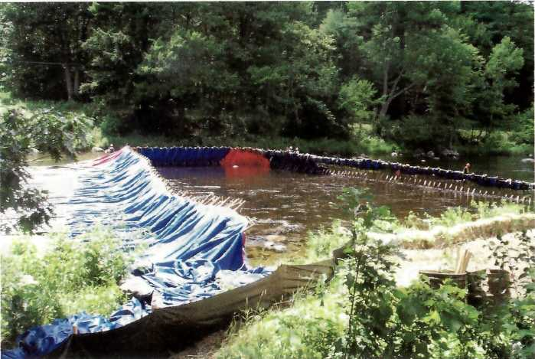
7 The Tennessee Gas Pipeline Company installed a cofferdam across the Farmington River to allow digging to replace its pipeline.

In the spring of 2002, the Farmington River Coordinating Committee (FRCC) reviewed the plans for a Tennessee Gas Pipeline Company (TGP) pipeline replacement project in the Wild and Scenic section of the Farmington River in Barkhamsted, Conn. The FRCC took its responsibility to provide input on the Army Corps permit a step further, creating a process through which stakeholders could also provide input into the project to improve, rather than degrade the habitat of the river.

TGP replaced a 6-inch pipe that crosses under the river with an 8-inch pipe. The project required placement of cofferdams in the river to allow workers to remove the old pipe and place the new pipe in a 6-foot deep trench. The Farmington River is about 150 feet wide at the pipeline crossing, with water depths usually between 1 and 2 feet. Habitat in the project area was not very good due to past work on the pipeline crossing.

Through the work of the FRCC and the state Department of Environmental Protection Inland Fisheries Division, an advisory group formed to oversee the project and ensure that this necessary but disruptive work would yield environmental and recreational benefits. The group coordinated habitat enhancement of the area—placement of boulders and rocks—and the replacement of access stairs near the pipeline crossing area, which is a popular fishing spot. Volunteers finished the project by replanting with native plants the river bank areas that had been cleared.
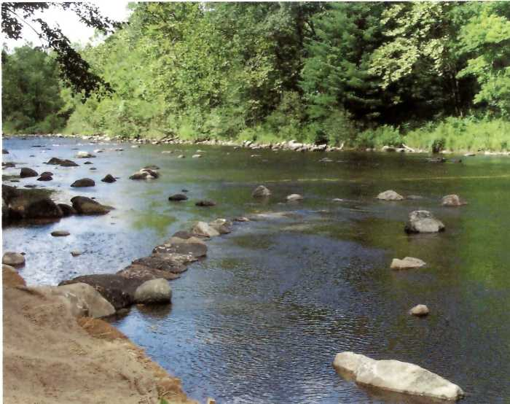
8 Placement of boulders and rocks across the Farmington River, in cooperation with the Connecticut Department of Environmental Protection Inland Fisheries, enhanced trout habitat in the disturbed area, which is also a popular fishing spot.

Farmington (West Branch)
14 miles flowing from Hartland to Canton, Connecticut
Designated in 1994

What is a Partnership Wild and Scenic River?

Over the past 20 years, river conservation interests at the local, state, and federal levels have worked collaboratively to use the National Wild and Scenic Rivers Act in an effective, partnership-based approach to national river conservation and designation. Once dubbed “Private Lands Rivers,” this growing collaborative of rivers has been recognized by the US Congress as a distinct and locally responsive application of the Wild and Scenic Rivers Act.

Partnership Wild and Scenic Rivers, as they are now referred to, are federally designated components of the National Wild and Scenic Rivers System that share the following:
- No lands are federally owned, and federal ownership and management are not authorized in legislation or recommended in the River Management Plan (see below).
- Administration of the designation and implementation of the Management Plan are accomplished through a broadly participatory “Council” or “Committee” organized on each river specifically for this purpose.
- Land use continues to be governed by local communities and state statutes, as prior to designation.
- On designated rivers the National Park Service is responsible for reviewing federally funded, sponsored or licensed projects to ensure federal consistency in preserving the identified “Outstandingly Remarkable Values” for which the river was designated. This responsibility is coordinated with each river’s council or committee. NPS is also authorized to provide technical and financial assistance to the river organizations.
- The River Management Plan is locally developed and implemented through a broadly participatory process. The plan is locally approved and endorsed by relevant state and federal authorities prior to federal designation. The plan forms the basis of the designation and guides post-designation management.
- The costs and responsibilities associated with managing and protecting river resources are shared among all of the partners—local, state, federal, and non-governmental. Landowner participation and volunteerism are essential elements of the partnership.

Outside of this basic, shared framework, Partnership Rivers vary widely in the details of their administration and management, which are based on their wide-ranging physical, biological, and political characteristics.

As new rivers are designated, the model will evolve and adapt. We hope and believe that the basic tenets outlined above can continue to serve as a guide for existing and future Partnership Wild and Scenic Rivers.
—A Message From the Partnership Rivers

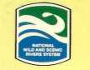Wild & Scenic Rivers—Partnership Program: Contact Information
Comments? Contact:

National Program Manager:
Charlie Stockman
Charlie_Stockman@nps.gov
202-354-6907

Northeast Program Managers:

Boston:
Jamie Fosburgh
Jamie_Fosburgh@nps.gov
617-223-5191

Philadelphia:
Chuck Barscz
Charles_Barscz@nps.gov
215-597-6482
 | Local Contacts | NPS Contacts
Farmington  River | Farmington River www.FarmingtonRiver.org | Liz_Lacy@nps.gov  860-379-0282
Great Egg  Harbor River | The Great Egg Harbor  Watershed Association www.greategg.org | Paul_Kenney@nps.gov  215-597-5823
Lamprey River | Lamprey River Advisory Committee www.lampreyriver.org | Margaret_Watkins@nps.gov  603-226-3240
Lower Delaware  River | Delaware River Greenway Partnership www.state.nj.us/drbc/wild_scenic.htm | William_Sharp@nps.gov  215-597-1655
Maurice River | Citizens United  www.cumauriceriver.org/pages/maurice.html | Paul_Kenney@nps.gov  215-597-5823
Sudbury, Assabet, and Concord Rivers | River Stewardship Council www.sudbury-Assabet-Concord.org | Lee_Steppacher@nps.gov  617-223-5225
Wekiva River | FL-DEP, Wekiwa Springs State Park www.floridastateparks.org/wekiwasprings | Wallace_Brittain@nps.gov  404-562-3175
White Clay Creek | White Clay Creek Watershed Association http://mercury.ccil.org/~wcwa/ | Charles_Barscz@nps.gov  215-597-6482

Helping communities preserve and manage their own rivers in the National Wild and Scenic Rivers System

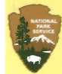National Park Service U.S. Department of the Interior
Partnership Rivers News is published by the Partnership Rivers in the Wild & Scenic Rivers Program.

Editor
Margaret Watkins

Program Manager
Charlie Stockman

Contributors
Fred Akers, Great Egg Harbor Watershed Association
Chuck Barscz, NPS
Julia Blatt, Organization for the Assabet River Paul Kenney, NPS
Liz Lacy, NPS
Bill Sharp, NPS
Judith Spang, Lamprey River Advisory Committee

Photographers
Delaware Department of Transportation
Richard Lord, Lamprey River Advisory Committee
Fred Akers, Great Egg Harbor Watershed Association
Frank Boffoli and Susan Flint, courtesy of Organization for Assabet River
The Nature Conservancy
Marion M. Kyde, PhD.
Don Mysling, CT DEP Inland Fisheries

Designer
Kelly Short, Canterbury Communications

For more information:
www.nps.gov/pwsr

The National Park Service cares for the special places saved by the American people so that all may experience our heritage.

EXPERIENCE YOUR AMERICA

