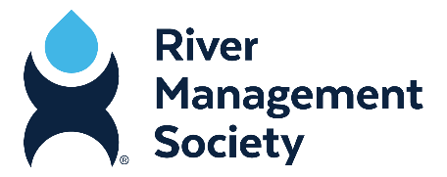
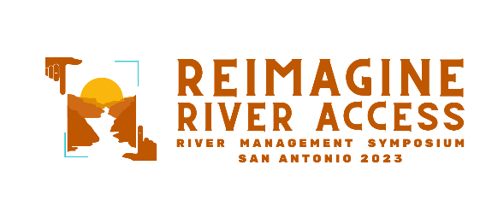
River Management Society Training Proposal

Dear Supervisor,

As part of my continued interest in improving my skills and abilities so that I can better serve this agency and our constituents, I would like to attend the biennial River Management Symposium next year. It will be held February 28 – March 2, 2023, in San Antonio, Texas. The theme is Reimagine River Access, covering the physical, social and economic aspects of river use, management and stewardship.

This training opportunity will showcase how the river management profession is adapting and thriving. It will offer training workshops required or recommended by agencies, watershed and water trails leaders, field scientists and students. Workshops will provide skills-based training for planners and practitioners, and presentations will explore innovative partnerships, success with diversifying funding sources, use of technology to streamline processes, strategies for inclusion and equity in river spaces, entrepreneurial solutions, adaptive reuse of aging facilities, cultivating political and community support, and tools that new and emerging river managers need in order to learn and lead.

Roughly 200 professionals from federal, state and local agencies, international agencies and organizations, the commercial sector, and academic institutions typically attend the biennial RMS Symposium. This diversity of professionals offers communication and networking opportunities that are essential for learning about real-life river management experiences, best practices, and tips.

This is an especially important year for me to keep up with the rapidly changing river management landscape and the role rivers play as an interface between recreation, public health and industries such as agriculture and hydropower. Rivers face economic and environmental challenges related to climate change and pressure from both energy development and recreation. Learning about strategies to deal with these changes and the specific tools my colleagues have already learned will enable me to recommend processes or policies that can move us up to and ahead of current trends in recreation, technology, stewardship.

Here’s an approximate breakdown of the training costs:

Registration: Airfare:
Hotel: Meals:
Total:

If I attend, I would submit a post-training summary, including a set of recommended actions to further our river management efforts. I’d also be more than happy to share relevant information with other staff members and departments. I thank you in advance for your consideration of this request, and I look forward to your reply.

Sincerely,

